SUSTAINABLE
STRATEGY WORKBOOK
REPORT TEMPLATES

Table of Contents

Great Strategies Report 2
Executive Summary 2
Introduction 2
Purpose 2
Strategy 2
Vision 3
Great Strategies Process 4
Build 4
Test 4
Great Strategies 5
Great Start Report 7
Get Ready 7
Plan to Plan 7
Stakeholder Analysis 7
Purpose 7
Values 7
Mission 7
Current Strategy 8
Lines of Business 8
Success Measures 8
Summary 9
Great Ideas Report 10
Vision Statement 10
Ideate 10
Statement 11
Vision Ideas 11
Collect 12
Evaluate 12
Great Ideas 12
References 14
Endnotes 14

Great Strategies Report
What should we do next?

Executive Summary

Introduction

Great Start

Great Ideas

Great Strategies

Purpose

Values

Values
Behaviors

Mission

Strategy

Lines of Business

 | Lines of Business
Lines of Business | Customer | Difference

Success Measures

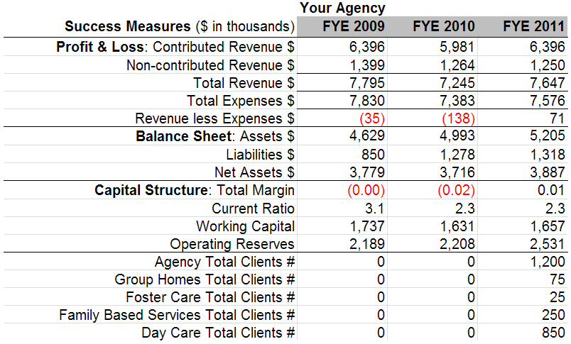

Vision

Statement

4BStrategies

5BGoals

Great Strategies Process

Build

Current

 |  | Current Strategies
 | Name of Strategy | Name of Strategy | Name of Strategy
People
Product
Place
Price
Proposition

New

 | New Strategies
 | Name of Strategy | Name of Strategy | Name of Strategy
People
Product
Place
Price
Proposition

Test

External Environment

Industry Environment

 | Industry Environment
 | Strategy | Strategy | Strategy
Industry Description
Relations Among
Existing Organizations
Funding Group Power
Fit to Strategy

Competitor Environment

 | Competitor Environment
 | Your Strategy | Your Strategy | Your Strategy
Competitor
Lines of Business
Competitive Advantages
Likely Response
Fit to Strategy

Internal Environment

Mission and Programs

Organizational Capacity

Capital Structure

Risk Orientation

Great Strategies

Decide

 | External Environment
 | Your Strategy | Your Strategy | Your Strategy
Industry Environment
Competitor Environment
Fit to Strategy

 | Internal Environment
 | Strategy | Strategy | Strategy
Mission and Programs
Organization Capacity
Capital Structure
Risk Orientation
Fit to Strategy

 | Change or Die Checklist
 | Strategy | Strategy | Strategy
Is the practice better than what you are doing now?
Is it really worth the time, disruption, and money?
Is it best to make only symbolic changes instead of core changes?
Is doing it good for you,
but bad for the company?
Do you have enough power to make it happen?
Are people already overwhelmed by
too many changes?
Will people be able to learn and update as it unfolds?
Will you be able to
pull the plug?
Fit to Strategy

Goals

 | Goals
Name of Strategy | Name of Strategy | Name of Strategy

Great Start Report
What are we doing now?

Get Ready

Plan to Plan

Stakeholder Analysis

Stakeholder | Principal Goals | Interest | Power

Purpose

Values

Values
Values
Behaviors

Mission

Who

What Difference

How Better

SVP Capacity Assessment Tool

Four Questions

 | Competitive Advantage(s)
 | A | B | C | D
Valuable
Rare
Costly to Imitate
Non-substitutable

Mission Statement

 | Mission Statement
Elements | Old Mission |  | New Mission
Who
What difference
Competitive advantage
Complete Statements
Current Mission |  | New Mission
Simplified Mission

Current Strategy

Lines of Business

 | Lines of Business
Lines of Business | Customer | Difference

Success Measures

4F

Summary

Great Ideas Report
What could we do next?

Vision Statement

Ideate

Customers

BOBs

Analysis

 | Best of the Best
Your Agency | BOB 1 | BOB 2
 | Lines of Business
 | Financials
Revenue: | Revenue: | Revenue:
Expenses: | Expenses: | Expenses:
Net Revenue: | Net Revenue: | Net Revenue:
Net Assets: | Net Assets: | Net Assets:
 | Competitive Advantages

Take Aways

Good Questions

 |  | Great Ideas from the Ansoff Matrix442F
 |  | Products
 |  | Existing | New
Market | Existing | Market Penetration | Product Development
Market | New | Market Development | Diversification

Stop Fix

 |  | Great Ideas from the MacMillan Matrix443F
 |  | Program Attractiveness
 |  | High |  | Low
 |  | Alternative Coverage
 |  | High | Low | High | Low
Competitive Position | Strong
Competitive Position | Strategy | Aggressive  Competition | Aggressive  Growth | Build Up  Best Competitor | Soul of  the Agency
Competitive Position | Weak
Competitive Position | Strategy | Aggressive  Divestment | Build Strength  or Bail Out | Orderly  Divestment | Joint Venture –  Foreign Aid

SWOT Analysis

Strengths and Weaknesses

 | Positive | Negative
Internal | Strengths | Weaknesses

Opportunities and Threats

 | Positive | Negative
External | Opportunities | Threats

BAM

BAM Ideas
Ideas (Affinity Grouped) | Group Name | Voting

Statement

Vision Ideas

Collect

All Ideas

Evaluate

First Cut

First Cut

Contenders

 | Contenders444F
 | Hard to Do | Easy to Do
Big
Pay-off
Little
Pay-off

Great Ideas

 |  | Finalists
Criteria | WT | A | B | C | D | E | F
Plays to competitive advantage
Brings Vision Statement to life
Total

References

Ansoff, H. I. (1957). Strategies for diversification. Harvard Business Review, 35(5), 113-124.
Blackwood, A., & Pollak, T. (2009). Washington-area nonprofit operating reserves Charting Civil Society (pp. 10). Washington: Center on Nonprofits and Philanthropy.
Glossary. (2010). Retrieved March 15, 2010, from http://www.charitynavigator.org/index.cfm?bay=glossary.list#W
Light, M. (2011). Results now for nonprofits: Purpose, strategy, operations, and governance. Hoboken, N.J.: John Wiley & Sons.
MacMillan, I. C. (1983). Competitive strategies for not-for-profit organizations. Advances in Strategic Management, 1, 61-82.
McLaughlin, T. A. (2009). Streetsmart financial basics for nonprofit managers (3rd ed.). Hoboken, N.J.: Wiley.
Ulrich, D., Kerr, S., & Ashkenas, R. N. (2002). The GE work-out: How to implement GE's revolutionary method for busting bureaucracy and attacking organizational problems--fast! New York: McGraw-Hill.

Endnotes

This report is built upon a template derived from Results Now for Nonprofits: Purpose, Strategy, Operations, and Governance (Light, 2011). All content herein © Mark Light, 2014. Thanks to Hillary Darville for editing and advice.
Total Margin: "This is the bottom line . . . the one [measure] that tough, no-nonsense managers of all stripes supposedly focus on single-mindedly"(McLaughlin, 2009, p. 83). Formula = Revenue minus Expenses [line 19] divided by Revenue [line 12] Current Ratio: "the most widely recognized measure of liquidity . . . the ratio should be at least 1” (McLaughlin, 2009, p. 75). Formula = Current Assets (lines 1-9) divided by Current Liabilities (lines 17 to 19) Working Capital: "Determines how long a charity could sustain its level of spending using its net available assets, or working capital, as reported on its most recently filed Form 990” ("Glossary," 2010). Formula = Unrestricted plus Temporarily Restricted Net Assets Operating Reserves: A more conservative view of working capital because you use unrestricted net assets and exclude land, building, and equipment, and temporarily restricted assets (Blackwood & Pollak, 2009, p. 9). Formula = Unrestricted Net Assets minus Land, Building, and Equipment plus Mortgages & Notes
Total Margin: "This is the bottom line . . . the one [measure] that tough, no-nonsense managers of all stripes supposedly focus on single-mindedly"(McLaughlin, 2009, p. 83). Formula = Revenue minus Expenses [line 19] divided by Revenue [line 12] Current Ratio: "the most widely recognized measure of liquidity . . . the ratio should be at least 1” (McLaughlin, 2009, p. 75). Formula = Current Assets (lines 1-9) divided by Current Liabilities (lines 17 to 19) Working Capital: "Determines how long a charity could sustain its level of spending using its net available assets, or working capital, as reported on its most recently filed Form 990” ("Glossary," 2010). Formula = Unrestricted plus Temporarily Restricted Net Assets Operating Reserves: A more conservative view of working capital because you use unrestricted net assets and exclude land, building, and equipment, and temporarily restricted assets (Blackwood & Pollak, 2009, p. 9). Formula = Unrestricted Net Assets minus Land, Building, and Equipment plus Mortgages & Notes
(Ansoff, 1957)
(MacMillan, 1983)
(Ulrich, Kerr, & Ashkenas, 2002)

